**HOSTEL MANAGEMENT SYSTEM**

**MINI PROJECT REPORT**

Submitted by:-

**NAME EMAIL-ID REGISTERED NUMBER**

**SHISHIR KUMAR(04)** [**shishir.kumar@viit.ac.in**](mailto:shishir.kumar@viit.ac.in) **+91-9113447571**

**SWAPNIL AHIRE (07)** [**swapnil.ahire@viit.ac.in**](mailto:swapnil.ahire@viit.ac.in) **+91-9423039277**

**SUBHRANIL BALA (11)** [**subhranil.bala@viit.ac.in**](mailto:subhranil.bala@viit.ac.in) **+91-9004171356**

**DEPARTMENT OF COMPUTER ENGINEERING**

**SCHOOL OF ENGINEERING**

**VISHWAKARMA INSTITUTE OF INFORMATION TECHNOLOGY,KONDHWA-411048**

**CERTIFICATE**

*Certified that this is a bonafide record of the project work entitled*

*“ONLINE HOSTEL MANAGEMENT SYSTEM”*

*done by the following students*

*SHISHIR KUMAR 323004*

*SWAPNIL AHIRE 323007*

*SUBHRANIL BALA 323011*

*Of the Vth semester, Computer Science and Engineering in the year 2018-19 in*

*partial fulfillment of the requirements to the award of Degree Bachelor of*

*Engineering in Computer Science and Engineering of Savitribai Phule Pune University.*

*Dr.Sachin Sakhare Mrs.Madhuri Chavan*

*(Head of the Department) (Subject Professor)*

*Place:Pune*

*Date:12/10/18*

**ACKNOWLEDGEMENT**

Here we gladly present this project report on **“ONLINE HOSTEL MANAGEMENT SYSTEM”** as part of the 5th semester B.E in Computer Science and Engineering. At this time of submitting this report we use this opportunity to mention those people who with us along the work. We take this occasion to thank God,almighty for blessing us with his grace and taking our endeavour to a successfulculmination. We extend our sincere and heartfelt thanks to our esteemed ***guide, Mrs. Madhuri Chavan*** for providing us with the right guidance and advice at the crucial juncturesand for showing us the right way. We extend our sincere thanks to our respected ***Head Of* *the Department Mr. Sachin Sakhare***, for allowing us to use the facilities available. We would like to thank the other faculty members also, at this occasion. Last but not the least; we would like to thank friends for the support and encouragement they have given us during the course of our work.

Submitted by

**SHISHIR KUMAR**

**SWAPNIL AHIRE**

**SUBHRANIL BALA**

**ABSTRACT**

“HOSTEL MANAGEMENT SYSTEM” is software developed for managing various activities in the hostel. For the past few years the numbers of educational institutions are increasing rapidly. Thereby the numbers of hostels are also increasing for the accommodation of the

students studying in this institution. And hence there is a lot of strain on the person who are running the hostel and software’s are not usually used in this context. This particular project deals with the problems on

managing a hostel and avoids the problems which occur when carried manually.

Identification of the drawbacks of the existing system leads to the designing of computerized system that will be compatible to the existing

system with the system which is more users friendly and more GUI oriented.

**INTRODUCTION**

**PROBLEM DEFINITION**

This system is designed in favour of the hostel management which helps them to save the records of the students about their rooms and other things. It helps them from the manual work from which it is very difficult to find the record of the students and the mess bills of the students, and the information of about the those ones who had left the hostel. All the hostels at present are managed manually by the hostel office. The Registration form verification to the different data processing is done manually. Thus there are a lot of repetitions which can be easily avoided. And hence there is a lot of strain on the person who are running the hostel and software’s are not usually used in this context. This particular project deals with the problems on managing a hostel and avoids the problems which occur when carried manually Identification of the drawbacks of the existing system leads to the designing of computerized system that will be compatible to the existing system with the system which is more user friendly. We can improve the efficiency of the system, thus overcome the drawbacks of the existing system. We design this system of the hostel management especially for the college hostel, through this they cannot require so efficient person to handle and calculate the things. This system automatically calculates all the bills and issued the notifications for those students who are against some rules.

**OBJECTIVES OF PROJECT**

This software product the hostel management to improve their services for all the students of the hostel. This also reduce the manual work of the persons in admin penal and the bundle of registers that were search when to find the information of a previous student, because through this system you can store the data of those students who had left the hostel . Through this you can check the personal profile of all the current students within few minutes the data base of the system will help you to check a particular one. The system will help you to check the mess bills of every student and the student’s hostel dues. The students of the hostel will be recognized from the ID number allocated at the room rental time. In the last this system will improve the management work in the hostel.

• To automate each and every activity of the manual system, which increases its throughput

• To provide a quick response with very accurate information as and when required

• To make the present manual system more interactive, speedy and user friendly

• To avail any information, whatever and whenever needed

• Reduce the cost of maintenance

**SYSTEM ANALYSIS**

**EXISTING SYSTEM**

The existing system is manual based and need lot of efforts and

consume enough time. In the existing system we can apply for the hostels online but the allotment processes are done manually. It may lead to corruptions in the allocation process as well as hostel fee calculation. The existing system does not deals with mess calculation and complaint registration.

DISADVANTAGES:-

• More human power

• More strength and strain of manual labour needed

• Repetition of same procedure.

• Low security.

• Data redundancy.

• Difficulty to handle.

• Difficulty to update data.

Record keeping is difficult.

• Backup data can be easily generated.

**PROPOSED SYSYTEM**

The proposed system is having many advantages over the existing system. It require less overhead and very efficient. The proposed system deals with the mess calculation and allotment process

efficiently.

* The New system is computerized version of the existing system.
* Provides easy and quick access over the data. Authorization schemes.
* Admin is easy to change or update the students details

SOFTWARE CONFIGURATION

Frontend : PHP 7.1.7,CSS3,JAVASCRIPT 1.8.5,HTML5

Backend : MYSQL 8.0,XAMPP SERVER

Operating system : Windows 10

**SYSTEM DESIGN**

Table for register_boys

|  |  |  |  |
| --- | --- | --- | --- |
| Sr No | Fields | Datatype | Constraints |
| 1 | Fname | Varchar(20) |  |
| 2 | Fbranch | Varchar(20) |  |
| 3 | Gname | Int | PRIMARY KEY ,NOT NULL |
| 4 | Cg | Float(5,2) |  |
| 5 | Pri_cat | Int |  |
| 6 | Category | Varchar(5) |  |
| 7 | Mob | Int |  |
| 8 | Pmob | Int |  |
| 9 | gen | Varchar(10) |  |

Table for register_girls

|  |  |  |  |
| --- | --- | --- | --- |
| Sr No | Fields | Datatype | Constraints |
| 1 | Fname | Varchar(20) |  |
| 2 | Fbranch | Varchar(20) |  |
| 3 | Gname | Int | PRIMARY KEY ,NOT NULL |
| 4 | Cg | Float(5,2) |  |
| 5 | Pri_cat | Int |  |
| 6 | Category | Varchar(5) |  |
| 7 | Mob | Int |  |
| 8 | Pmob | Int |  |
| 9 | gen | Varchar(10) |  |

TABLE FOR USERS:-

|  |  |  |  |
| --- | --- | --- | --- |
| Sr No | Fields | Datatype | Constraints |
| 1 | Id | Int | PRIMARY KEY |
| 2 | Username | Int(10) |  |
| 3 | Email | Varchar(30) |  |
| 4 | password | Varchar(30) |  |

**Activity Diagram for Admin**



**Activity Diagram for Student**



USE CASE DIAGRAMS

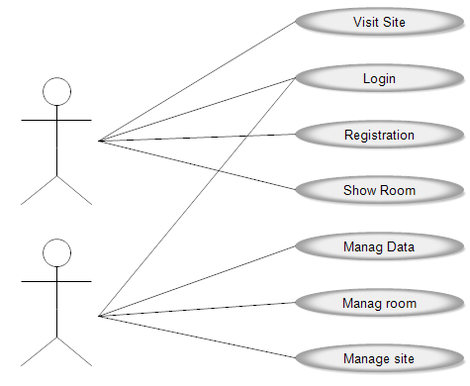

E-R Diagram:-

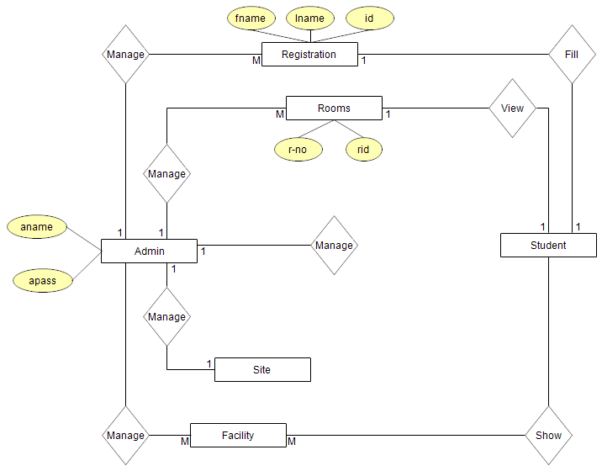

**SYSTEM TESTING**

As the part of system testing we execute the program with the intent of finding errors and missing operations and also a complete verification to determine whether the objectives are met and the user requirements are satisfied. The ultimate aim is quality assurance. Tests are carried out and the results are compared with the expected document. In the case of

erroneous results, debugging is done. Using detailed testing strategies a test plan is carried out on each module. The various tests performed are unit testing, integration testing and user acceptance testing.

**Unit Testing**

The software units in the system is are modules and routines that are assembled and integrated to perform a specific function. As a part of unit testing we executed the program for individual modules independently. This enables, to detect errors in coding and logic that are contained within each of the three module. This testing includes entering data that is filling forms and ascertaining if the value matches to the type and entered into the database. The various controls are tested to ensure that each performs its action as required.

**Integration Testing**

Data can be lost across any interface, one module can have an adverse effect on another, sub functions when combined, may not produce the desired major functions. Integration testing is a systematic testing to discover errors associated within the interface. The objective is to take unit

tested modules and build a program structure. All the modules are combined and tested as a whole. Here the admin module, sec module and student module options are integrated and tested. This testing provides the assurance that the application is well integrated functional unit with smooth transition of data.

**User Acceptance Testing**

User acceptance of a system is the key factor for the success of any system. The system under consideration is tested for user acceptance by constantly keep the records of applicants and making changes to the details and password whenever required.

**CONCLUSION**

To conclude the description about the project: The project developed using PHP and MySQL is based on the requirement specification of the user and the analysis of the existing system, with flexibility for future enhancement.

The expanded functionality of today’s software requires an appropriate approach towards software development. This hostel management software is designed for people who want to manage various activities in the hostel. For the past few years the numbers of educational institutions are increasing rapidly. Thereby the numbers of hostels are also increasing for the accommodation of the students studying in this institution. And hence there is a lot of strain on the person who are running the hostel and software’s are not usually used in this context. This

particular project deals with the problems on managing a hostel and avoids the problems which occur when carried manually.

Identification of the drawbacks of the existing system leads to the designing of computerized system that will be compatible to the existing system with the system which is

more user friendly and more GUI oriented.

**BIBLOGRAPHY**

Murach’s PHP and MySQL – Joel Murach &Ray Harris  
Software engineering - Roger S. Pressman  
PHP and MySQL- Bible

**REFERENCE SITE**

* [http://www.TutorialPoint.com](http://www.tutorialpoint.com/)
* [http://www.w3schools.com](http://www.w3schools.com/)

PROJECT IMAGES:-

